NCC Education Candidate ID number | P00201736
Candidate Name | Amaan Al Mir
Examination Date | 14 June 2023
Examination Module Title | Network Security and Cryptography

Authorised Equipment
All equipment other than that listed below is not permitted in the examination room.
- Word processing device (Laptop, desktop computer, tablet)
- Graph paper, scientific calculator (when stated on the front of the question paper), ruler, pens

NCC Education Time Constrained Assessments (TCAs) are NOT Open Book assessments. If you are found with any other materials during the period of the assessment, it will be assumed that they are being used to gain unfair advantage.

Instructions to Candidates

Answer Booklet for use with NCC Education TCAs

- Ensure you have entered your details correctly at the top of the page and entered the question numbers you have attempted in the table below.
- Candidates may use a word processing device to complete their assessment
- Candidates must rely on their own knowledge when answering the TCA question and that using other sources is not required or expected.
- At the end of the assessment, remain seated and do not communicate with any other candidate until you are told by the invigilator that you can leave the assessment.
- Completed copies of candidates’ answers must be submitted in Microsoft Word or PDF, no other files types will be accepted.
- All diagrams, graphs, code or other non-text portions of examinations should be embedded in the document or added to the electronic answer booklet to make 1 single file per student.
- Candidates must submit their completed answers to their centre by the centres given deadline. Your Centre will inform you of the method by which you must submit your completed answer script.
- Candidates attempting to communicate or gain an unfair advantage in any way will be disqualified from this assessment and may be excluded from any other NCC Education qualification.

Questions Answered

Please insert the question numbers you have answered in the table below.
Question number attempted  (To be completed by the Candidate) | Marks Awarded  (To be completed by the marker)
Question 1 a
Question 1 b
Question 2 a
Question 2 b
Question 3 a
Question 3 b
Question 4 a
Question 4 b
 | TOTAL MARKS:

Question 1 (a):
1. One-way hash functions are easy to compute but very difficult to compute. This hashing method can be used to encrypt passenger credentials stored on the website’s database to ensure integrity.

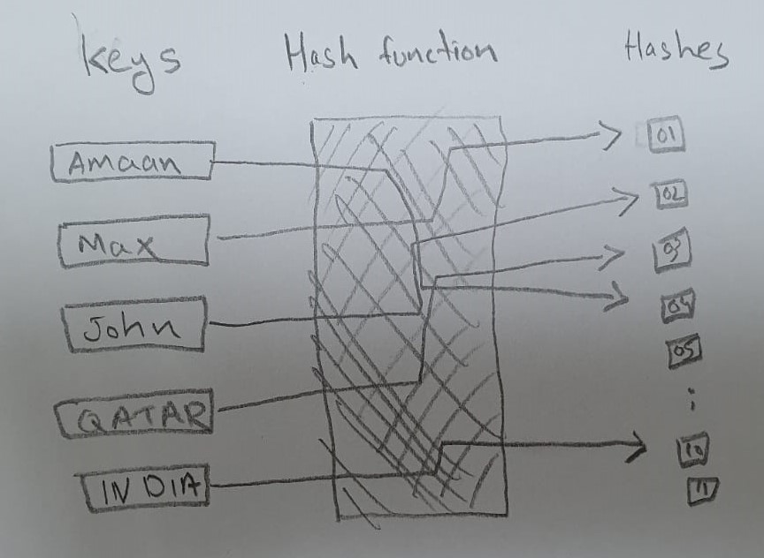

2. Here are two methods that can be used to improve password-based authentication on the company’s website:
1. Encrypting the password using MD5 hashing algorithm to ensure integrity.
2. Forcing users to enable to Two-Factor Authentication (2FA) on their accounts. This will help the business protect their customer’s personal information as it prevents attackers from reading, copying or modifying their data.

Question 1 (b):

Here are few steps to secure the company’s wireless network:
1. Based on the scenario, the company’s current wireless (Wi-Fi) network is open. The first step in securing this line of communication is to close and hide the network from public access.

2. Installing a VPN (Virtual Private Network) to encrypt and hide the data transferred through the network.
3. Applying password-based authentication to limit access to authorized staff only like shared-key authentication. This includes methods like Wired Equivalent Privacy (WEP), Wi-Fi Protected Access (WPA), WPA2, or WPA3. I’d recommend to go with WPA3 as it is more advanced and latest technology in the market for securing wireless networks.

4. Using end-to-end encryption to secure the network and ensure integrity.
5. Access can be controlled via access to access point (AP)

6. Allowing only authorized devices to connect to the network and blocking any unknown device.

7. Another way is applying MAC (Media Access Control) address filtering.
8. Installing a firewall to control the traffic.
9. Moving the route to a physically secured position and limit access to authorized staff. Also, by changing the default login credentials.
10. Keeping the softwares and firmwares up to date to fix any known vulnerability.

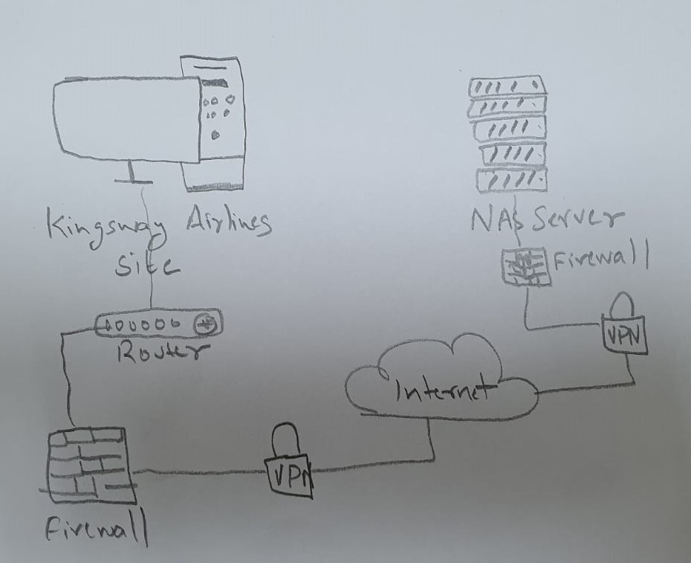
Question 2 (a):

- Here are two methods that can be used to check if the any vulnerabilities in Microsoft Windows Server has been patched:
1. Running Microsoft Windows built-in update checker will display all the patches applied to their latest build so that users may install the corresponding patches and update their system.
2. Using the vulnerability code or title (like CVE) to search online, either on internet or the CVE online database to get the latest news.

- Here are two methods that could have been used to prevent cyberattack:
1. If the company had an authentication system on their wireless network, it could have been difficult for the attackers to gain access.
2. If the company had their Microsoft Windows Server up-to-date, the hackers couldn’t have exploited the known vulnerability which gave them administrator rights to internal IT systems.

Question 2 (b):

Here are two methods to secure the travel tickets send by customer server advisor to passengers:
1. Encrypting documents sent via email.
The company could use encrypt the documents sent via email using Public and Private key cryptography. Public Key Cryptography is the encryption & decryption and signing/verification of data.

- This will ensure the privacy between service advisor and customers by preventing disclosure of the data.
- It also ensures that the data has not be modified.

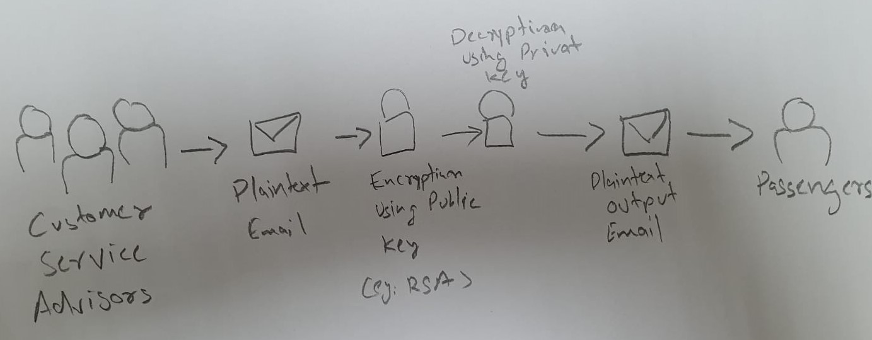

2. Installing a VPN (Virtual private network) on customer service computers:

A VPN can be installed to encrypt the emails sent through the Internet. It can help encrypt the entire mail including header details like sender’s and receiver’s email addresses, subject, and body.

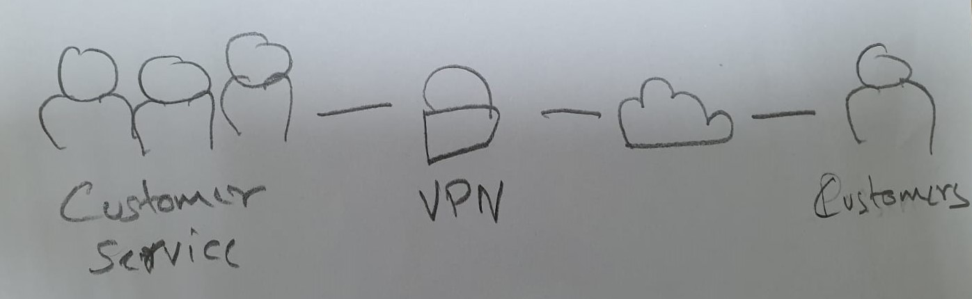

Question 3 (a):

Here are two methods that can be used to protect the copies of all passenger’s personal information and tickets customer service computer and the backed-up data on Network attached storage.

- Installing a VPN (virtual private network) on the customer service advisor’s computer can encrypt their connection to the internet and prevent attackers from gaining unauthorized access to their system and reading, copying or modifying passenger information or travel tickets.
A firewall can also be installed to block incoming and outgoing traffic to prevent non-customers from send malicious content to customer service computer and also prevent the advisor from opening any malicious links.
Using strong passwords can also help in protecting the computer from unauthorized access.

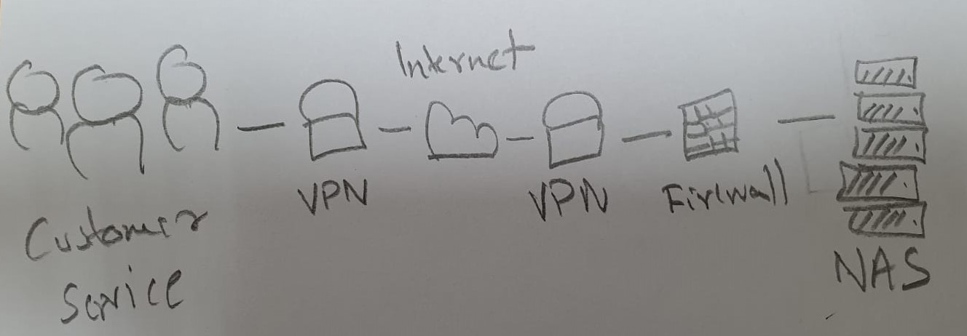
- Here are steps to protect the Network-attached storage (NAS):
a. Change the default login credentials:
When setting up a NAS system, you can login using default credentials which are widely known and can be used by attackers to easily gain access to the system. By changing this and creating complex password, is the first step in securing the NAS drive.
b. Enable Two-Factor Authentication (2FA):
This adds an extra layer to security and prevents anybody from gaining access to your system unless they have physical access to your 2FA device.
c. Enable SSL (Secure Socket Layer):
An SSL will provide an encrypted connection to the NAS if you want to access the data stored in the drive remotely. This mean using HTTPS instead of HTTP which is more secured and prevent attackers from gaining access to login credentials easily.
d. Install VPN (a virtual private network):
Connecting NAS via a VPN is the best way to secure the NAS. This will use a private port and prevent anybody from gaining unauthorized access to the drive.
e. Enable firewalls:
A firewall allows you to recognize a trusted connection or device and block all other connections preventing anybody from gaining unauthorized access.
For example, you can also a connection using their IP Address or a device using their MAC address or block all connections from a certain region or country.
f. Regularly update the software:
Out of date software can allow attackers to exploit a known vulnerability to gain access to the system. Keeping your software up-to-date will patch all known vulnerabilities, and bugs.
Question 3 (b):
A DMZ (Demilitarized Zone) is separate part of the network used to control the traffic and protect the network.
1. A packet inspection firewall tracks and monitors of active connections to the networks. It also analyses incoming traffic for potential threats and risks that can harm the network or the data stored in it.
It checks for following between the connected devices and connections:
- Protocol
- New or existing connection
- IP Address
- Port numbers
By examining these details, it decides which connections to block or allow through the firewall. Most of the time it only checks the header of the connection to check whether it’s a trusted connection but latest softwares can also scan the data for viruses and other threats.
For outbound traffic, when a user tries to connect to an IP address, the firewall checks whether the packet is allowed or blocked on the current set of rules. It also checks whether it’s a legitimate HTTP traffic. If these requirements are met, an entry with session information is created in the firewall translation table to allow the packet to pass through.
Inbound traffic checks whether the return traffic is allowed by comparing the incoming session information with the information stored in local translation table. It the information matches, it is forwarded to the user.
2. Here are some limitations of packet inspection firewalls:
- It is open to certain Denial-of-service (DoS) attacks which can be used fill the connection table with illegitimate connections.
- There are no client or server model.
- It is complicated and hard to configure and manage.
- It does not support authenticated connections.
Question 4 (a):
1. A VPN, or Virtual Private Network, creates a secure and encrypted connection between two or more devices over public internet. It creates a secure tunnel to protect the data from being altered or read by unauthorized users.
A VPN can be installed to allow remote customer service advisors to securely connect to the company's Network-attached storage from their homes via public internet. This way the company’s data will be encrypted and secured, from being altered or read by unauthorized individuals and other spyware softwares.

2. The most suitable type of VPN for this scenario is Remote Access VPN.
This type of VPN connections are encrypted connections
between corporate networks and remote users. This will help
remote customer service advisors connect to the company's Network-attached storage from anywhere that has access to the internet. The Remote Access VPN connection can provide secure access to the passenger’s information and travel tickets while maintaining the confidentiality and integrity of the data.

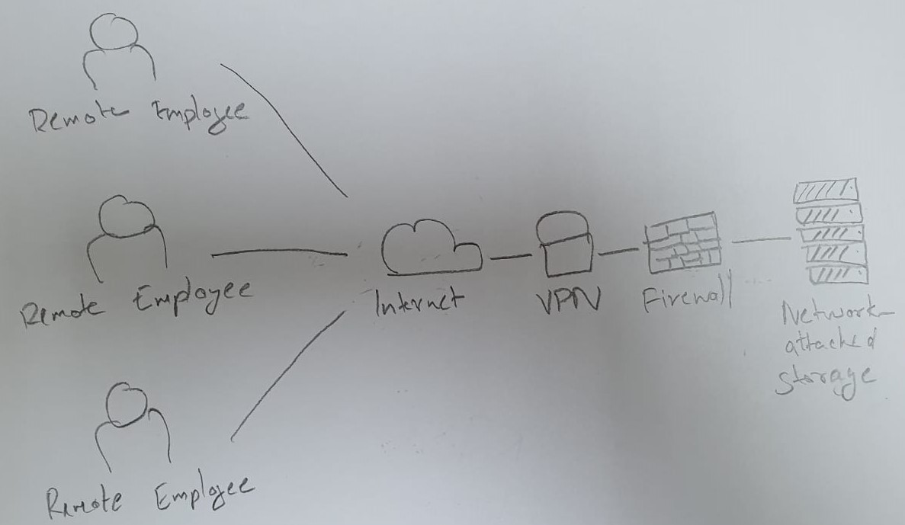
Question 4 (b):
Difference between HTTP and HTTPS connection
HTTP | HTTPS
It stands for “HyperText Transfer Protocol” | It stands for “HyperText Transfer Protocol Secure”
It works at the application layer | It works at the transport layer
The default port number is 80 | The default port number is 443
No kind of encryption is present | Both encryption and decryption exists
Connection is not secured | Connection is secured
Vulnerable to cyberattacks | Can withstand such attacks

If the website is using HTTPS, most browsers will show a padlock or some other symbol to indicate that the website is secured and using SSL or TLS.

When the website is back online, I would enable SSL, a Secure Socket Layer to protect the website from harmful attacks.
An SSL provides a transport layer security. It uses TCP to provide a reliable and secure end-to-end encrypted service.

Steps to ensure the website is using HTTPS when it is back online:
- Check the SSL Certificate: A secure URL starts with https instead of http. The extra ‘s’ in https stands for secure which means it using a SSL certificate.
- Look the padlock icon near the URL bar in the browser to ensure the website is secured.

